**Technical Details Documentation**

**Flow Chart of EazeFin**

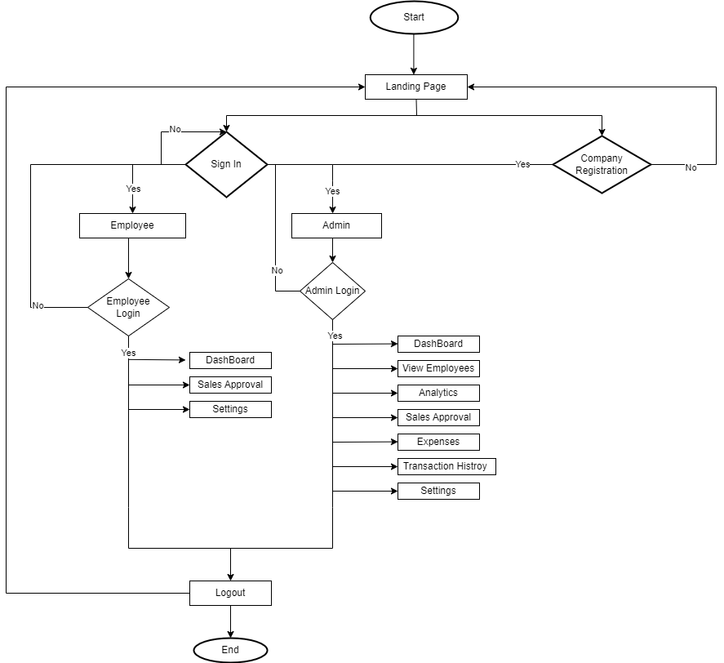

|  |  |
| --- | --- |
| **Symbol** | **Name** |
| Shape | **Start/End** |
| Shape | **Activity/Process** |
| Shape | **Decision** |
| Shape | **Flow Line** |

**Database Schema of EazeFin**

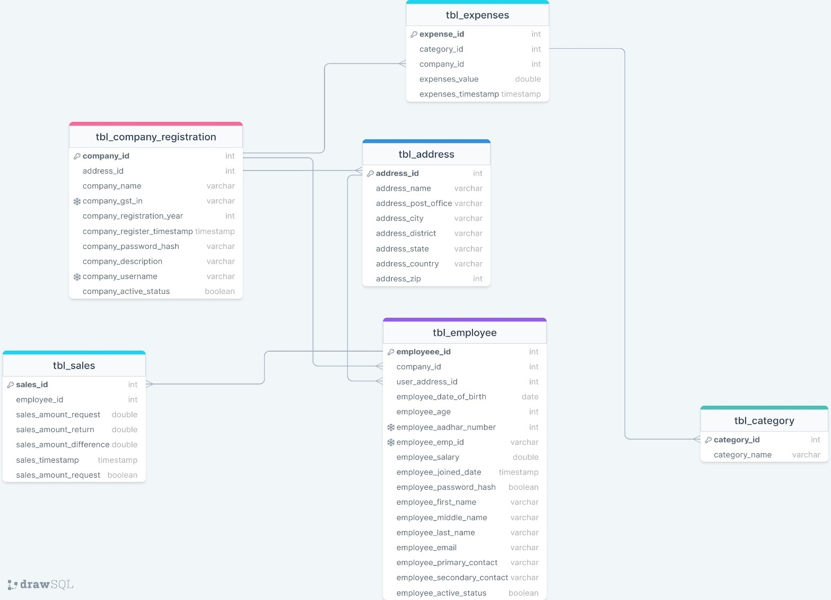

**Software Required**

IDE:

* Eclipse IDE for Enterprise Java and Web Developers - 2022-09
* Visual Studio Code

Database:

* Oracle MYSQL Workbench (8.0.32 Community)

Webserver:

* The Apache Tomcat (9.0.68)

Version Control:

* Git (2.37.3.1)
* GitHub

Testing:

* Selenium